Parabolic-Curve Generator

Definition
# Source: AI Source: Provided by: [Data Path: Persons Table -> ID Column: 1, Name_En Column: Motasem Essam] -> From: [ChatGPT] on [7/25/2026]
A Parabolic-Curve Generator is a curved-line generator that uses a parabola as its generating element to produce a geometric surface or solid through a prescribed movement, particularly rotation or translation.
A parabola is an open plane curve consisting of points that are equally distant from a fixed point called the focus and a fixed straight line called the directrix.
When a parabola rotates around its axis of symmetry, it generates a Paraboloid of Revolution, also called a Circular Paraboloid.
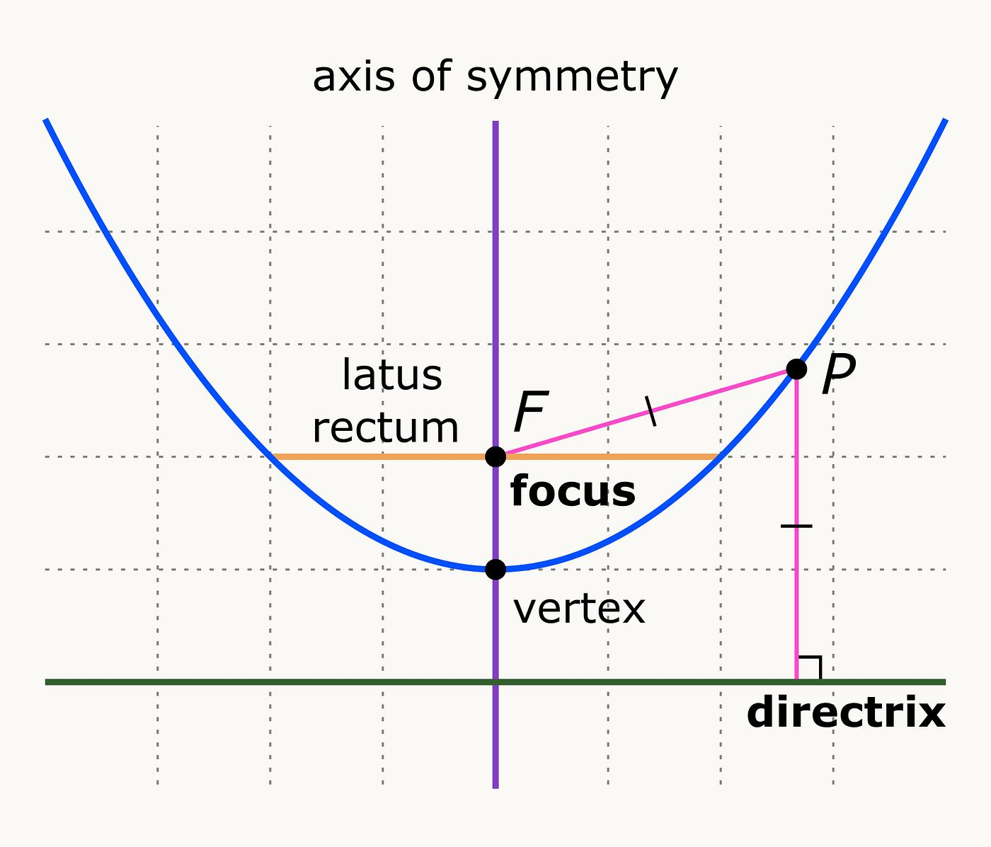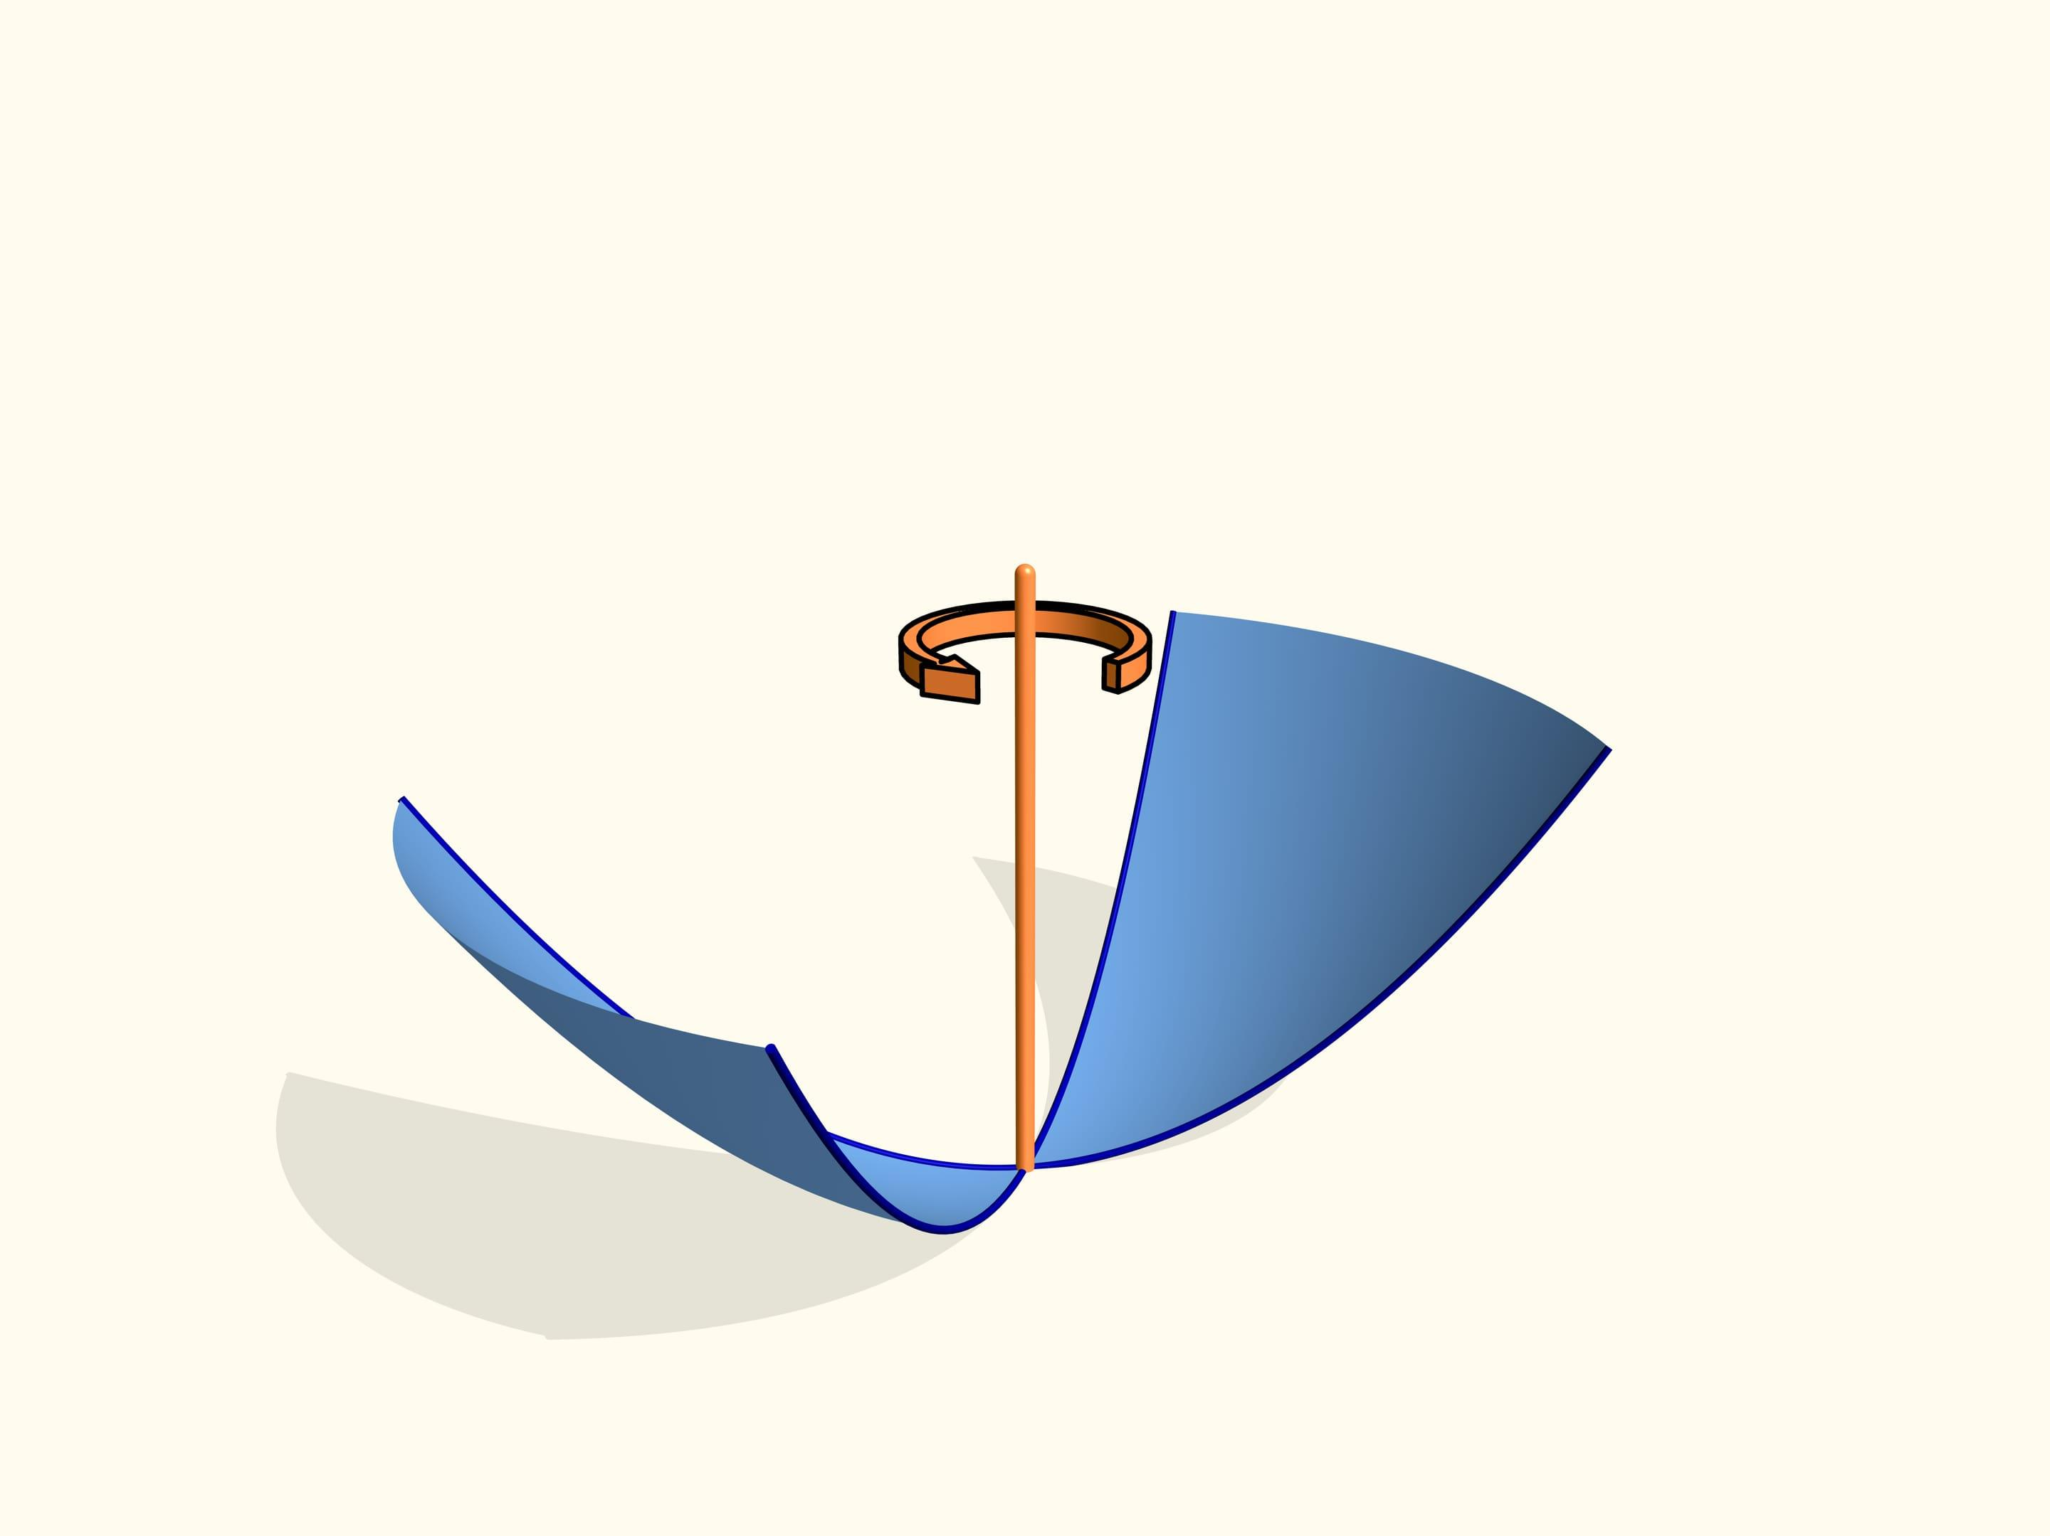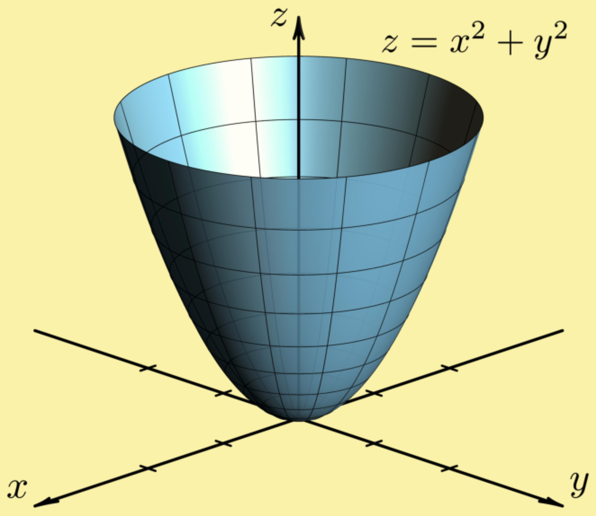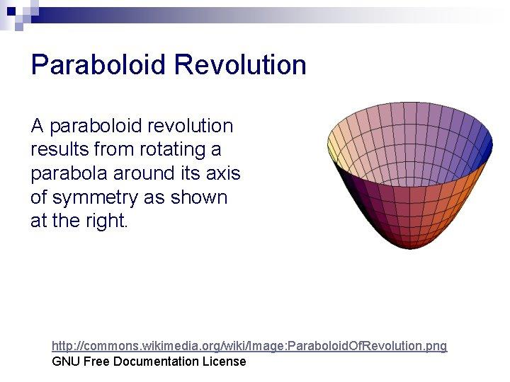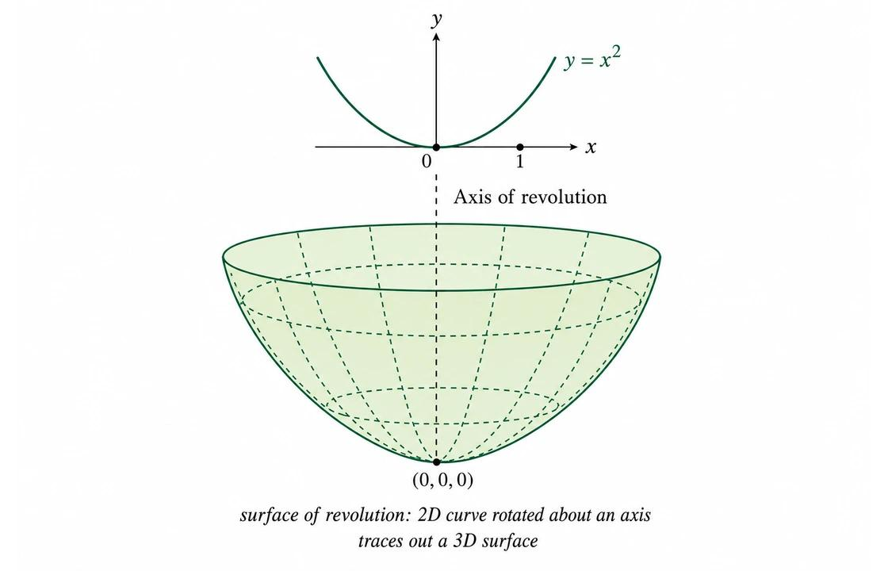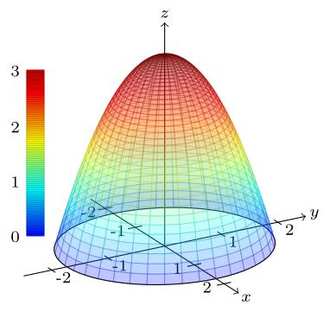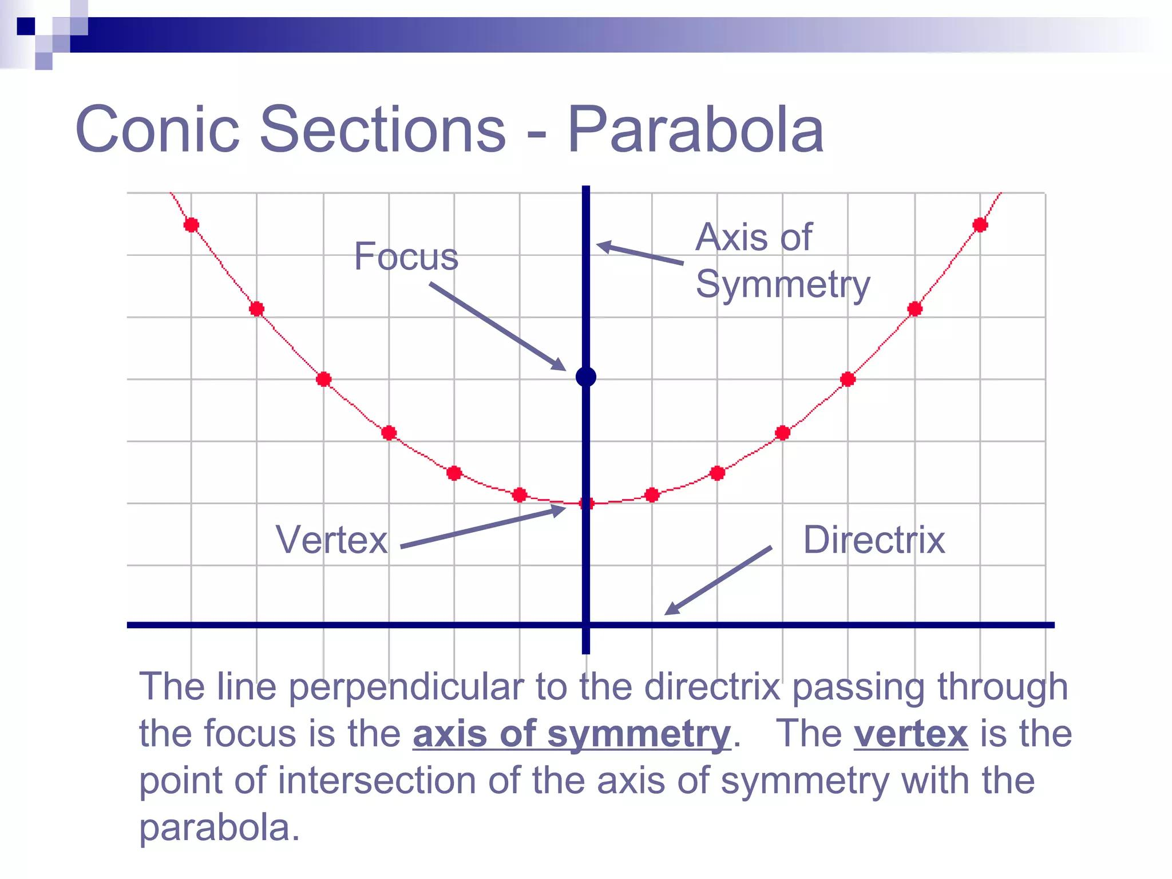
Main generating principle:
- Generating curve → Parabola.
- Fixed geometric reference → Axis of rotation or guiding path.
- Moving curve → Parabolic generator.
- Generated surface → Paraboloid or another surface of revolution, depending on the motion.

Geometric Structure
# Source: AI Source: Provided by: [Data Path: Persons Table -> ID Column: 1, Name_En Column: Motasem Essam] -> From: [ChatGPT] on [7/25/2026]
A parabolic-curve generator consists of the following elements:
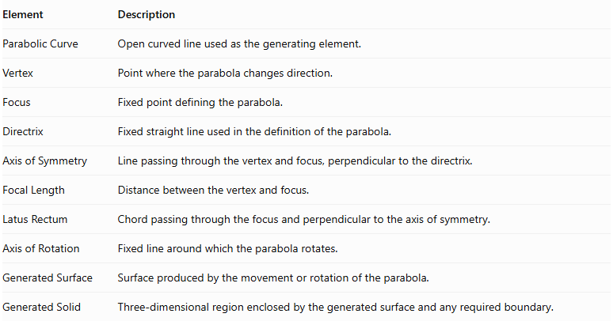
Element | Description
Parabolic Curve | Open curved line used as the generating element.
Vertex | Point where the parabola changes direction.
Focus | Fixed point defining the parabola.
Directrix | Fixed straight line used in the definition of the parabola.
Axis of Symmetry | Line passing through the vertex and focus, perpendicular to the directrix.
Focal Length | Distance between the vertex and focus.
Latus Rectum | Chord passing through the focus and perpendicular to the axis of symmetry.
Axis of Rotation | Fixed line around which the parabola rotates.
Generated Surface | Surface produced by the movement or rotation of the parabola.
Generated Solid | Three-dimensional region enclosed by the generated surface and any required boundary.

Types of Parabolic Curves
# Source: AI Source: Provided by: [Data Path: Persons Table -> ID Column: 1, Name_En Column: Motasem Essam] -> From: [ChatGPT] on [7/25/2026]
Parabolic curves can be classified according to their opening direction and position.

Upward-Opening Parabola
# Source: AI Source: Provided by: [Data Path: Persons Table -> ID Column: 1, Name_En Column: Motasem Essam] -> From: [ChatGPT] on [7/25/2026]
An Upward-Opening Parabola is a parabola whose two branches extend upward from its vertex.
Its standard equation is:
$$y={ax}^{2}, a>0$$
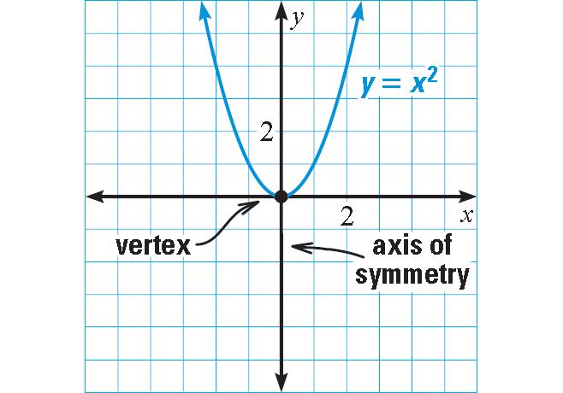

Downward-Opening Parabola
# Source: AI Source: Provided by: [Data Path: Persons Table -> ID Column: 1, Name_En Column: Motasem Essam] -> From: [ChatGPT] on [7/25/2026]
A Downward-Opening Parabola is a parabola whose two branches extend downward from its vertex.
Its standard equation is:
$$y=-{ax}^{2}, a>0$$
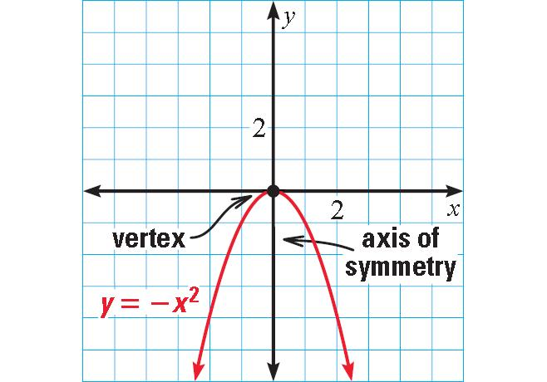

Right-Opening Parabola
# Source: AI Source: Provided by: [Data Path: Persons Table -> ID Column: 1, Name_En Column: Motasem Essam] -> From: [ChatGPT] on [7/25/2026]
A Right-Opening Parabola is a parabola whose branches extend toward the positive horizontal direction.
Its standard equation is:
$$y^{2}=4px, p>0$$
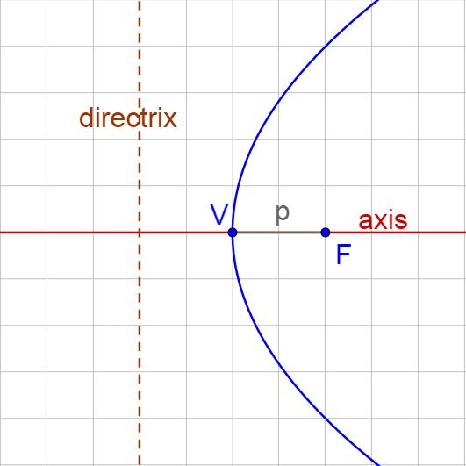

Left-Opening Parabola
# Source: AI Source: Provided by: [Data Path: Persons Table -> ID Column: 1, Name_En Column: Motasem Essam] -> From: [ChatGPT] on [7/25/2026]
A Left-Opening Parabola is a parabola whose branches extend toward the negative horizontal direction.
Its standard equation is:
$$y^{2}=-4px, p>0$$
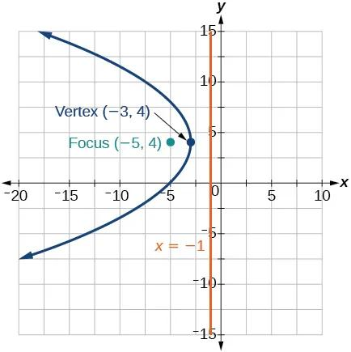
These orientations describe the generating curve before its movement or rotation.

Types According to the Axis of Rotation
# Source: AI Source: Provided by: [Data Path: Persons Table -> ID Column: 1, Name_En Column: Motasem Essam] -> From: [ChatGPT] on [7/25/2026]
When a parabolic curve rotates around an axis, it generates a surface of revolution. The resulting surface depends on the relationship between the parabola and the rotation axis.

Rotation About the Axis of Symmetry
# Source: AI Source: Provided by: [Data Path: Persons Table -> ID Column: 1, Name_En Column: Motasem Essam] -> From: [ChatGPT] on [7/25/2026]
When a parabola rotates around its axis of symmetry, it generates a Paraboloid of Revolution.
Generated surface: Circular Paraboloid.
Characteristics:
- The rotation axis coincides with the parabola's axis of symmetry.
- The vertex lies on the rotation axis.
- Every point on the parabola traces a circular path around the axis.
- The resulting surface has circular cross-sections perpendicular to its axis.
- The surface is an elliptic paraboloid with rotational symmetry.

Rotation About an Axis Parallel to the Axis of Symmetry
# Source: AI Source: Provided by: [Data Path: Persons Table -> ID Column: 1, Name_En Column: Motasem Essam] -> From: [ChatGPT] on [7/25/2026]
When a parabola rotates around a parallel axis that does not coincide with its axis of symmetry, it generates another surface of revolution.
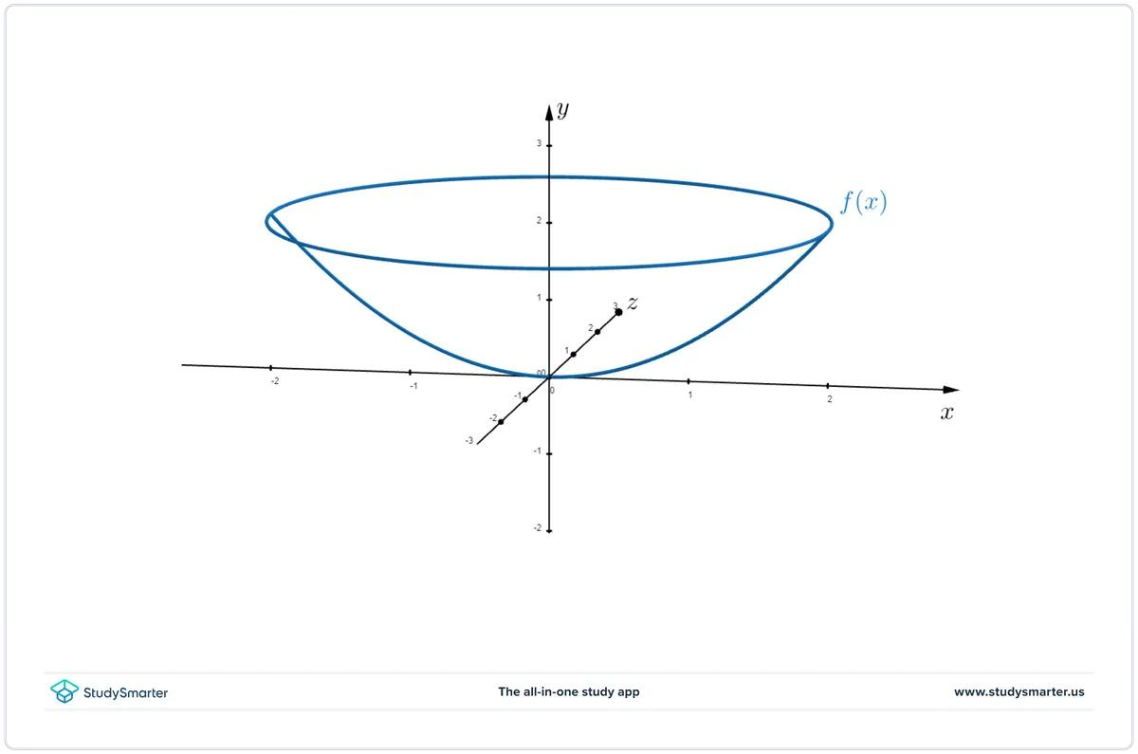
Generated surface: A surface of revolution with an offset rotational axis.
Characteristics:
- The rotation axis is parallel to the parabola's symmetry axis.
- The axis does not pass through the vertex.
- The generated surface is generally not a standard paraboloid of revolution.
- Its cross-sections and shape depend on the distance between the two axes.

Rotation About an Axis Perpendicular to the Axis of Symmetry
# Source: AI Source: Provided by: [Data Path: Persons Table -> ID Column: 1, Name_En Column: Motasem Essam] -> From: [ChatGPT] on [7/25/2026]
When a parabola rotates around an axis perpendicular to its symmetry axis, it generates a different surface of revolution.
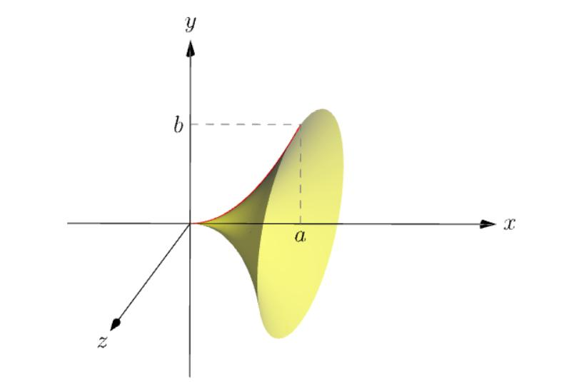
Characteristics:
- The rotation axis is perpendicular to the parabola's symmetry axis.
- The resulting surface is generally not a standard paraboloid.
- Its geometry depends on the location of the rotation axis and the selected portion of the parabola.
Important distinction: The standard paraboloid of revolution is generated by rotating a parabola about its own axis of symmetry. The other arrangements generate more general surfaces of revolution.

Mathematical Representation
# Source: AI Source: Provided by: [Data Path: Persons Table -> ID Column: 1, Name_En Column: Motasem Essam] -> From: [ChatGPT] on [7/25/2026]
Consider a right-opening parabola with its vertex at the origin.
Its equation is:
$$\boxed{y^{2}=4px}$$
Where:
- $p$: Distance from the vertex to the focus.
- Vertex: $(0,0)$.
- Focus: $(p,0)$.
- Directrix: $x=-p$.
- Axis of symmetry: $y=0$.

Parametric Equation of the Parabola
# Source: AI Source: Provided by: [Data Path: Persons Table -> ID Column: 1, Name_En Column: Motasem Essam] -> From: [ChatGPT] on [7/25/2026]
A standard parametric representation is:
$$x={pt}^{2}$$
$$y=2pt$$
where $t$ is a real parameter.

Paraboloid of Revolution Representation
# Source: AI Source: Provided by: [Data Path: Persons Table -> ID Column: 1, Name_En Column: Motasem Essam] -> From: [ChatGPT] on [7/25/2026]
When the parabola rotates around the $x$-axis, the resulting surface is:
$$\boxed{beginalignedx\&={pt}^{2}\backslash y\&=2ptcosφ\backslash z\&=2ptsinφendaligned}$$
Where:
- $p$: Focal length of the generating parabola.
- $t$: Parameter along the parabola.
- $φ$: Rotation angle around the $x$-axis.
Eliminating the parameters gives:
$$\boxed{y^{2}+z^{2}=4px}$$
This is the equation of a circular paraboloid opening in the positive $x$-direction.
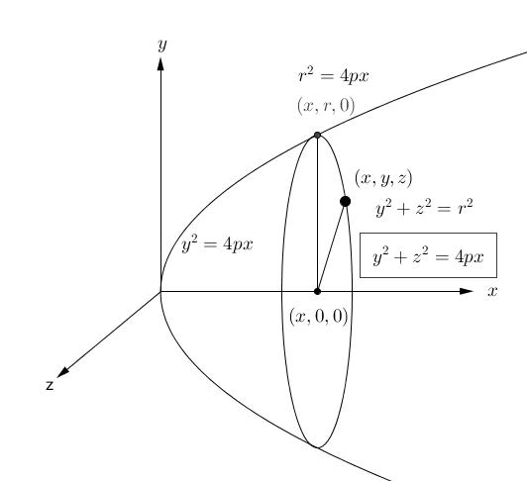

Generated Surfaces and Solids

Circular Paraboloid
# Source: AI Source: Provided by: [Data Path: Persons Table -> ID Column: 1, Name_En Column: Motasem Essam] -> From: [ChatGPT] on [7/25/2026]
A Circular Paraboloid is a surface generated by rotating a parabola around its axis of symmetry.
Characteristics:
- Has a single vertex.
- Has circular cross-sections perpendicular to its axis.
- Opens in one direction.
- Has rotational symmetry around its axis.
- Is a special type of elliptic paraboloid.

Solid Paraboloid
# Source: AI Source: Provided by: [Data Path: Persons Table -> ID Column: 1, Name_En Column: Motasem Essam] -> From: [ChatGPT] on [7/25/2026]
A Solid Paraboloid is the three-dimensional region enclosed by a paraboloid and a plane cutting it perpendicular to its axis.
It can be generated by rotating the region bounded by a parabola, its axis of symmetry, and a suitable cutting line.
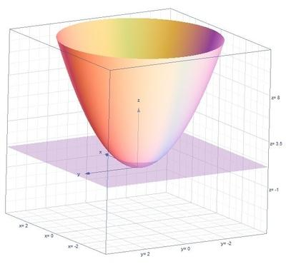
Characteristics:
- Has a curved parabolic surface.
- Has a circular planar base when cut perpendicular to its axis.
- Has a vertex at the pointed end.
- Its cross-sections perpendicular to the axis are circular disks.

Paraboloidal Segment
# Source: AI Source: Provided by: [Data Path: Persons Table -> ID Column: 1, Name_En Column: Motasem Essam] -> From: [ChatGPT] on [7/25/2026]
A Paraboloidal Segment is the portion of a solid paraboloid bounded by its curved surface and a plane perpendicular to its axis.
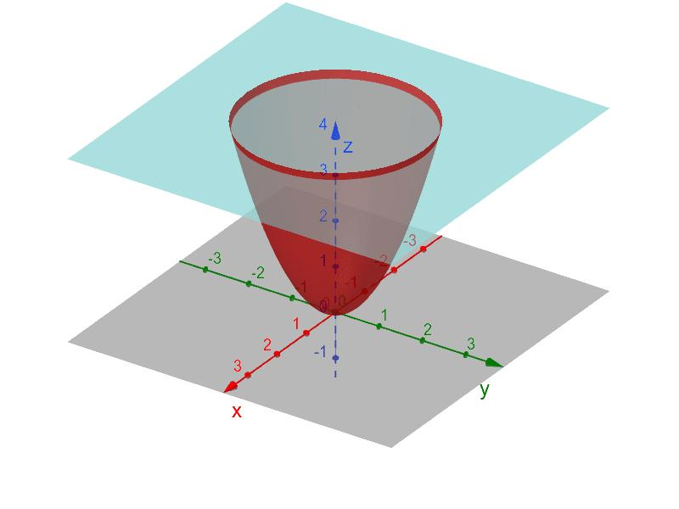
Its volume is:
$$\boxed{V=\frac{1}{2}πr^{2}h}$$
Where:
- $r$: Radius of the circular base.
- $h$: Height measured from the vertex to the base plane.

Geometric Measurements and Formulas
# Source: AI Source: Provided by: [Data Path: Persons Table -> ID Column: 1, Name_En Column: Motasem Essam] -> From: [ChatGPT] on [7/25/2026]
For a circular paraboloid:
$$y^{2}+z^{2}=4px$$
At a distance $h$ from the vertex along the axis, the radius of the circular cross-section is:
$$\boxed{r=2\sqrt{ph}}$$
Therefore:
Base radius:
$$r=2\sqrt{ph}$$
Height:
$$h=\frac{r^{2}}{4p}$$
Base area:
$$A_{b}=πr^{2}$$
Volume of the paraboloidal segment:
$$\boxed{V=\frac{1}{2}πr^{2}h}$$
Lateral surface area:
$$A_{l}=\frac{πr}{6p^{2}}\left[(r^{2}+4p^{2})^{3/2}-8p^{3}\right]$$
Here $p$ is the focal length of the generating parabola.

Mathematical Properties
# Source: AI Source: Provided by: [Data Path: Persons Table -> ID Column: 1, Name_En Column: Motasem Essam] -> From: [ChatGPT] on [7/25/2026]
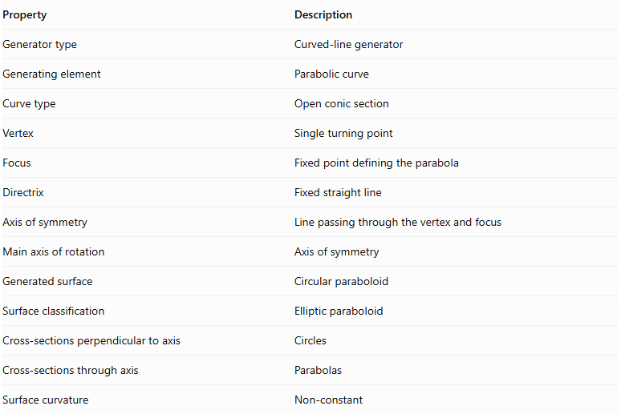
Property | Description
Generator type | Curved-line generator
Generating element | Parabolic curve
Curve type | Open conic section
Vertex | Single turning point
Focus | Fixed point defining the parabola
Directrix | Fixed straight line
Axis of symmetry | Line passing through the vertex and focus
Main axis of rotation | Axis of symmetry
Generated surface | Circular paraboloid
Surface classification | Elliptic paraboloid
Cross-sections perpendicular to axis | Circles
Cross-sections through axis | Parabolas
Surface curvature | Non-constant

Applications
# Source: AI Source: Provided by: [Data Path: Persons Table -> ID Column: 1, Name_En Column: Motasem Essam] -> From: [ChatGPT] on [7/25/2026]
Parabolic generators and their resulting surfaces are used in several fields:
- Optical Reflectors: Paraboloidal surfaces concentrate parallel incoming light rays at a focal point.
- Satellite Dishes: Parabolic reflectors focus incoming radio waves.
- Automobile Headlights: Paraboloidal reflectors direct light into a beam.
- Solar Collectors: Parabolic surfaces concentrate sunlight.
- Architecture: Paraboloidal forms are used in roofs and structural designs.
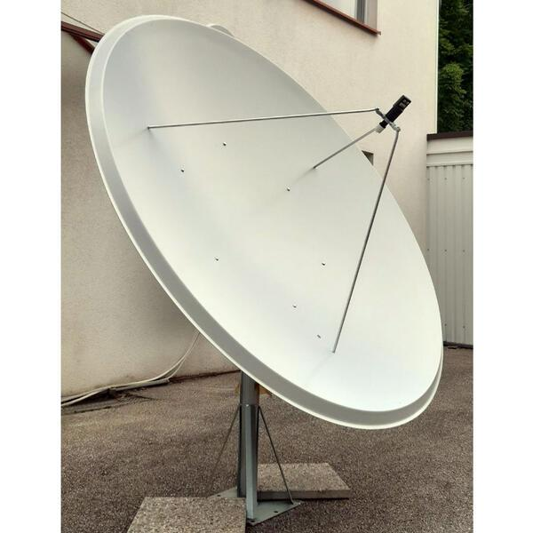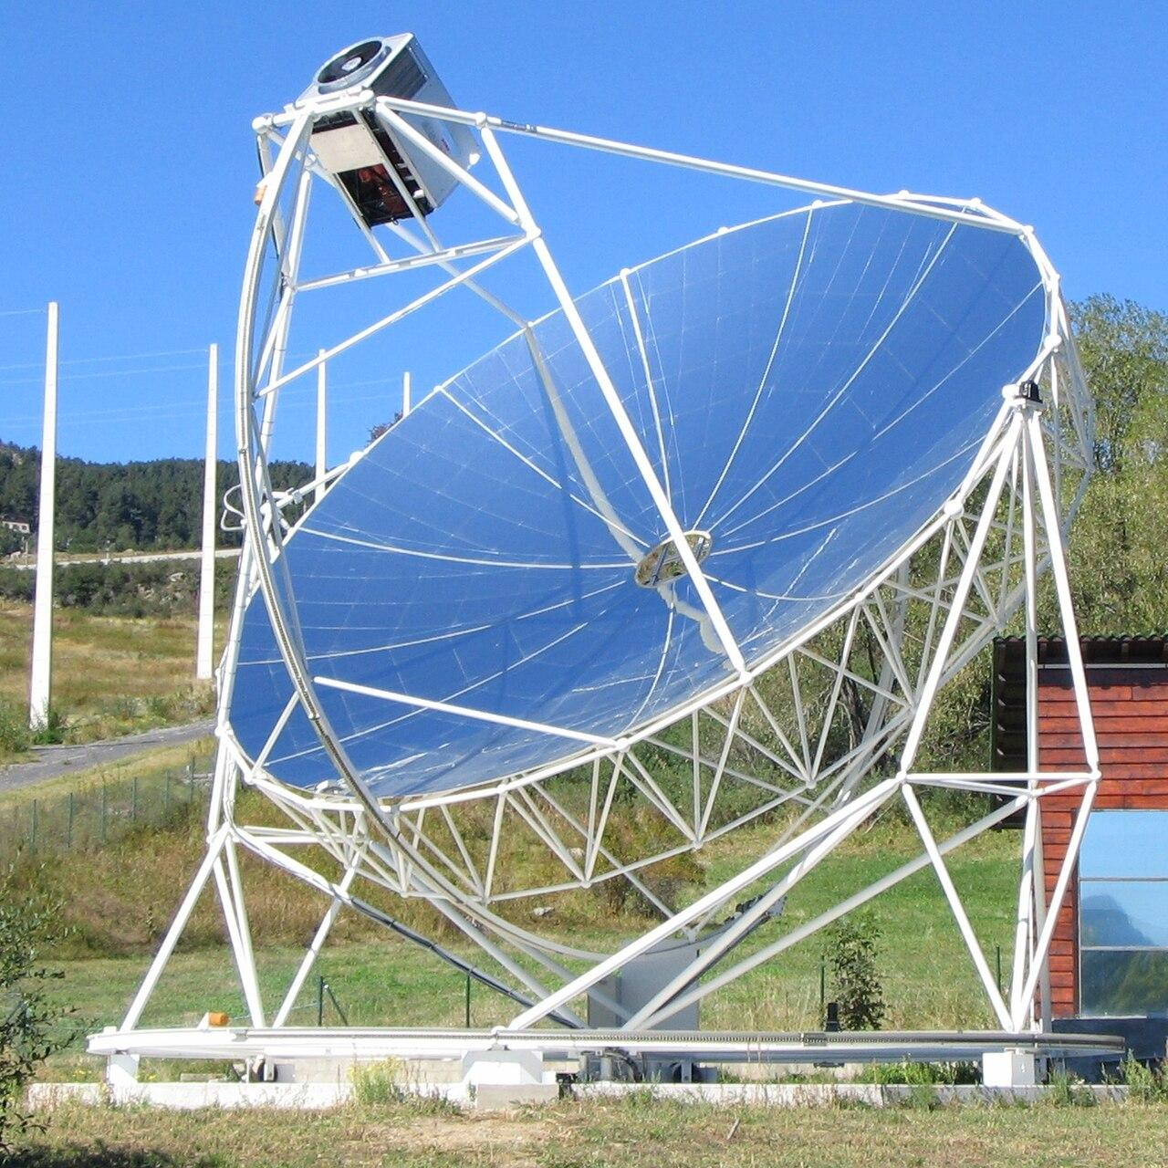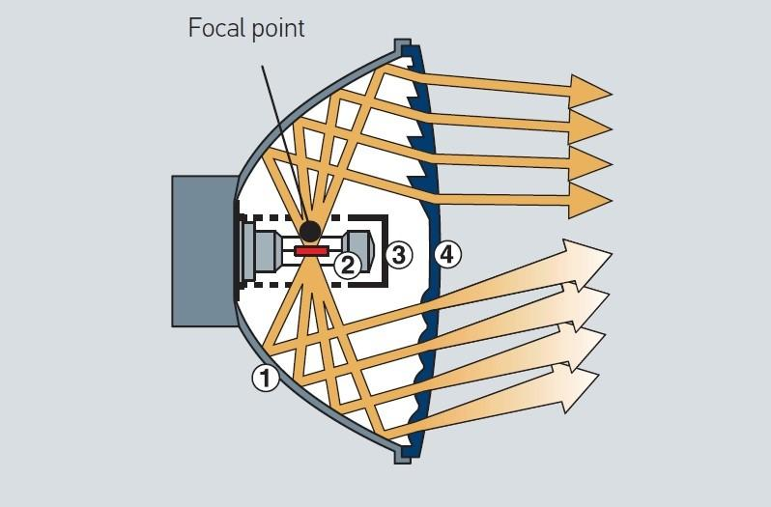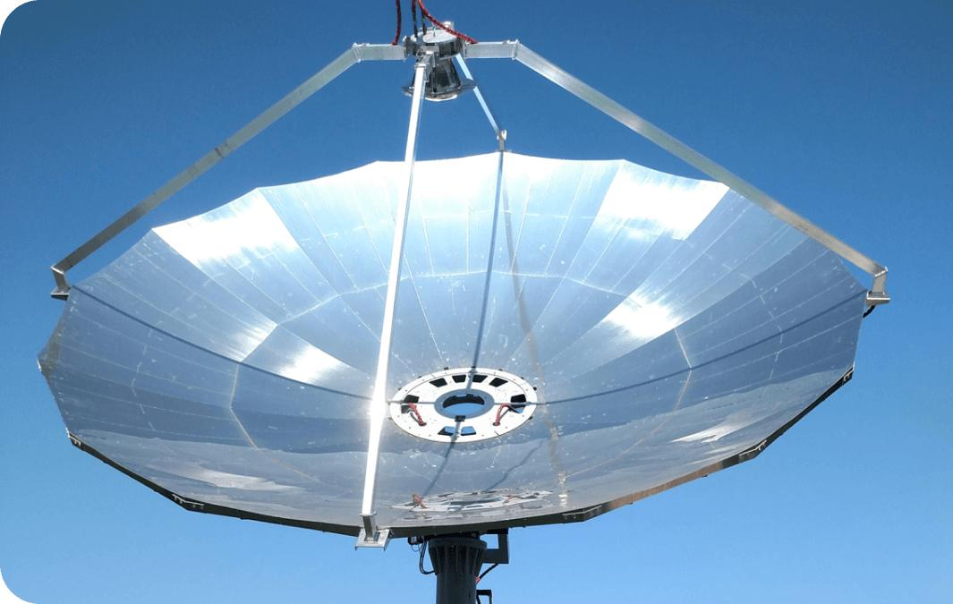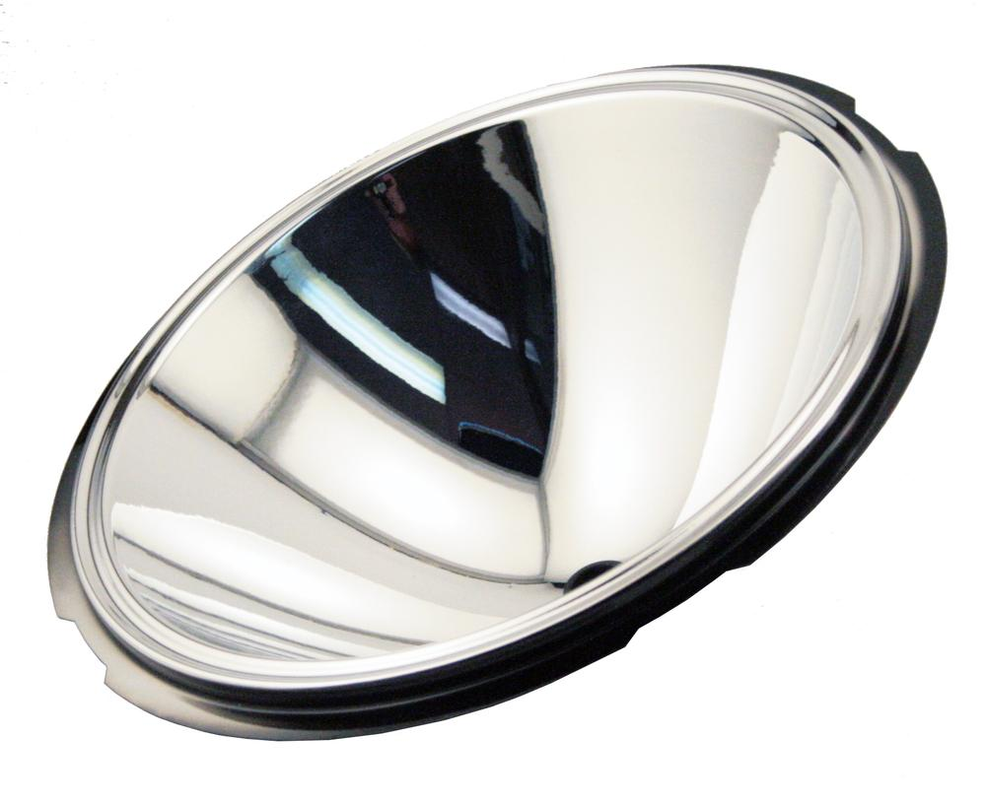

Comparison with Other Curved-Line Generators
# Source: AI Source: Provided by: [Data Path: Persons Table -> ID Column: 1, Name_En Column: Motasem Essam] -> From: [ChatGPT] on [7/25/2026]
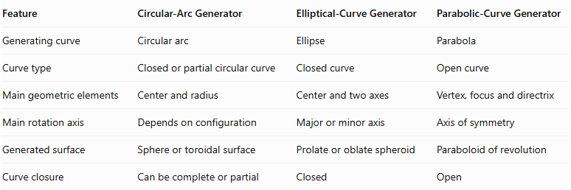
Feature | Circular-Arc Generator | Elliptical-Curve Generator | Parabolic-Curve Generator
Generating curve | Circular arc | Ellipse | Parabola
Curve type | Closed or partial circular curve | Closed curve | Open curve
Main geometric elements | Center and radius | Center and two axes | Vertex, focus and directrix
Main rotation axis | Depends on configuration | Major or minor axis | Axis of symmetry
Generated surface | Sphere or toroidal surface | Prolate or oblate spheroid | Paraboloid of revolution
Curve closure | Can be complete or partial | Closed | Open

Main Classification
# Source: AI Source: Provided by: [Data Path: Persons Table -> ID Column: 1, Name_En Column: Motasem Essam] -> From: [ChatGPT] on [7/25/2026]
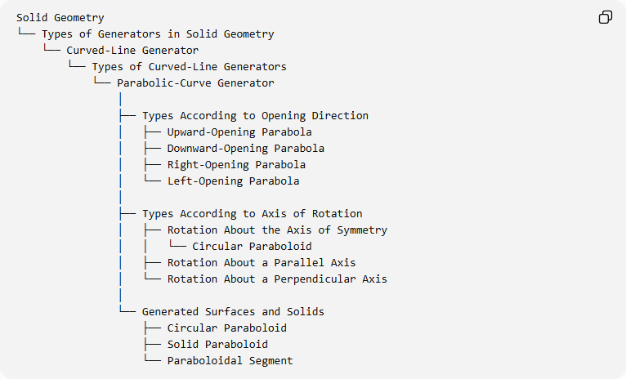
Solid Geometry
└── Types of Generators in Solid Geometry
└── Curved-Line Generator
└── Types of Curved-Line Generators
└── Parabolic-Curve Generator
│
├── Types According to Opening Direction
│ ├── Upward-Opening Parabola
│ ├── Downward-Opening Parabola
│ ├── Right-Opening Parabola
│ └── Left-Opening Parabola
│
├── Types According to Axis of Rotation
│ ├── Rotation About the Axis of Symmetry
│ │ └── Circular Paraboloid
│ ├── Rotation About a Parallel Axis
│ └── Rotation About a Perpendicular Axis
│
└── Generated Surfaces and Solids
├── Circular Paraboloid
├── Solid Paraboloid
└── Paraboloidal Segment

Key Points
# Source: AI Source: Provided by: [Data Path: Persons Table -> ID Column: 1, Name_En Column: Motasem Essam] -> From: [ChatGPT] on [7/25/2026]
- A parabolic-curve generator uses a parabola as its generating element.
- A parabola is defined by its focus and directrix.
- Its principal geometric elements include the vertex, focus, directrix, and axis of symmetry.
- Rotating a parabola around its axis of symmetry generates a circular paraboloid.
- A circular paraboloid is a special type of elliptic paraboloid.
- Rotating the bounded region around the axis generates a solid paraboloid.
- Cutting the solid with a plane perpendicular to its axis produces a paraboloidal segment.
- Paraboloidal surfaces have important applications in reflectors, satellite dishes, and solar collectors.

Conclusion
# Source: AI Source: Provided by: [Data Path: Persons Table -> ID Column: 1, Name_En Column: Motasem Essam] -> From: [ChatGPT] on [7/25/2026]
The Parabolic-Curve Generator is an important type of curved-line generator in solid geometry. Its principal generating operation is rotation around the parabola's axis of symmetry, producing a circular paraboloid.
It provides the geometric foundation for understanding paraboloidal surfaces, solid paraboloids, and their practical applications.

